Tanta Medical Journal Vol. (36), January 2008

Original Article

Serum Level Of Cartilage Oligomeric Matrix Protein As A Marker For Joint Damage In Patients With Osteoarthritis
Al-Sayed El-Manzalawy; Faisal Omran; Noha Abd Elnasser*
Esmail H. Mahmoud *† & Bashier Hamza **‡
Rheumatology Department, Faculty of Medicine, Al-Azhar & Benha" Universities & Clinical Pathology Department, Health Authority Hospitals, Riyadh, KSA† & Abu Dhabi, UAE‡

ABSTRACT
Objectives: This multicenter research was designed to assess the diagnostic applicability of serum cartilage oligomeric matrix protein (COMP) estimation in patients with atraumatic knee pain so as to define osteoarthritis (OA) patients.
Patients & Methods: The study comprised 100 females with atraumatic knee pain in either knee joints for > 15 days & 20 blood donors who served as the control group for serum COMP levels. The included cases subjected to a comprehensive history, clinical examination, and extent of patient mobility assessment via mobility score & pain severity assessment via a visual analogue scale (VAS). Through the Kellgren-Lawrence scoring system (K-L score), anteroposterior knee radiographs of all cases were assessed. Based on the radiological findings, patients were categorized to 2 presumed groups: group A: included 44 cases, with mild radiographically determined OA & pain with no dubious, group B: included 56 cases with pain & radiographically determined OA. All patients and control provided venous blood samples for measurement of serum COMP levels by ELISA.
Results: Patients had significantly higher COMP serum levels than control group and in group B than both controls & group A, with significantly higher level in group A than control. COMP serum levels were negatively correlated with mobility score and positively correlated with age, BMI, radiological grade & pain VAS score. Evaluation of clinical parameters vs serum COMP levels for distinguishing between cases with & without OA radiological findings using ROC curve analysis determined by AUC defined estimation of serum COMP had the highest AUC of 0.689%. Determination of the disease-specific cutoff value for serum COMP using ROC curve analysis. The 1430 ng/ml cutoff point is more specific than the 1370 ng/ml cutoff point, with AUC values of 0.770 and 0.431, respectively.
Conclusion: In cases with atraumatic knee pain, serum COMP levels evaluation may utilized as a screening test to define those with liability of developing OA and to diagnose patients already had OA with high sensitivity rate 76.4% at level of 1370 ng/ml and high specificity rate of 86.4% at level of at 1430 ng/ml.

INTRODUCTION

Osteoarthritis (OA) is a widely widespread illness, and its prevalence is projected to rise dramatically as a larger proportion of the population ages beyond 60 years. OA is a condition with a complex aetiology involving subchondral bone, ligaments, synovium, articular cartilage, and/or the neuromuscular system in a significant proportion. OA result in decline in life quality, pain & disability. Previous injury, age, increasing BMI, excessive workload & genetics are hazards for knee OA onset & development, ⁽¹⁾.
Articular cartilage is a multiphasic substance having 2 major phases at least: a solid phase composed of chondrocytes dispersed in lacunae and matrix components including proteoglycans & collagen and a fluid phase made up of electrolytes & water. Hyaline cartilage's extracellular matrix comprises an elaborated network of collagen fibrillar, which is crucial for appropriate tissue function, mechanical stability & a part of tensile strength. Cartilage collagen fibrils are composed of lipids, non-collagenous matrix proteins, proteoglycans, collagen II, which is prevalent in cartilage & collagens IX & XI, ⁽²⁾.
Type II collagen with large, aggregating proteoglycans, and smaller, non-aggregating proteoglycans, forms a network of fibers. Proteoglycans are proteins that contain covalently attached glycosaminoglycans, with water between them. The large aggregating proteoglycans, called "aggrecans", form aggregates that bind hyaluronic acid and together with collagen they are responsible for cartilage mechanical properties. The formation of collagen fibres is limited by fibromodulin, decorin & small non-aggregating proteoglycans, ⁽³⁾. Chondrocalcin and the N- propetide of Type II collagen in the cartilage matrix participate in fiber formation, while other proteins; chondronectin, fibronectin, vitronectin and thrombospondin take part in the interaction between the chondrocytes and the matrix, ⁽⁴⁾.
In OA, chondrocytes increase their biosynthetic activity, including the production of type II collagen, for damage compensation due to articular cartilage degeneration. The procollagen type II amino & carboxy -terminal propeptides are separated from the helical domain only after secretion, when the molecules reach the extracellular region. The non-helical domains at the end. The concentration & release of c-propeptides from cartilage are closely associated with collagen synthesis, ⁽⁵⁾.
COMP, the extracellular matrix protein is a member of the thrombospondin family, ⁽⁶⁾. COMP contains 5 (87 kDa) subunits linked together by interchain disulfide to produce a 435 kDa molecular weight pentameric protein. COMP is expressed in all cartilage types, ⁽⁷⁾. A developmentally controlled COMP localization in the chondrocyte territorial and interterritorial matrix was demonstrated by immunohistochemical labelling of articular cartilage, ⁽⁸⁾. In a zinc-dependent way, COMP link to collagen I, II & IX, ⁽⁹⁾. COMP's core domains comprise type 2 (EGF) and type 3 (calmodulin-like) repetitions, ⁽¹⁰⁾.
OA biological markers are articular tissue metabolism indicators that detect the molecules amounts originating from joint structures in urine, serum, & synovial fluids. OA diagnosis is based on radiological findings but visualizing the figures that have already occurred is a weak point. Estimating articular metabolism using biological markers is crucial for determining disease activity and monitoring disease progression. Synovial fluid precisely reflects the condition of a punctured joint, regardless of how invasive the procedure. Newly developed serum and urine markers that are less invasive may also be useful in OA diagnosis, ⁽¹¹⁾.
This prospective research was designed to determine the diagnostic applicability of COMP serum levels estimation in cases with atraumatic knee pain so as to define OA patients.

PATIENTS & METHODS

This double-blinded multicenter study was conducted at Health Authority Hospitals, Abu Dhabi, UAE and Afif General Hospital, Riyadh, KSA. After approval of the study protocol and obtaining patients' written consent, all female cases attended the Rheumatology outpatient clinic were enrolled in the study if they had atraumatic Knee pain in either of the knee joints for >15 days.
Determination of the patient's age, height, weight & BMI. All patients were evaluated clinically with respect to the history, onset, pain site, as well as a history of similar knee or other joint disorders, pain response to activities, aggravating or alleviating variables, existence and location of stiffness, grinding, swelling, locking or snapping, catching, fever or chills, and alterations in sensory or muscular strength. VAS (a 100 mm-scale, with "0" signifying no pain and "100" representing the greatest pain ever) was used to measure the intensity of the pain, ⁽¹²⁾. Also determined was the mobility score, which approximates the patient's mobility from being able to bedridden (scoring 0) to being walk and shop alone (scoring 9), ⁽¹³⁾.

Clinical evaluation involved visual inspection for fractures & dislocations, swelling presence & location, foot pulses, crepitus, warmth, & tenderness. Pain & anxiety with lateral patellar displacement, active & passive motion range, varus/valgus instability joint line pain with extension or flexion. Additionally, the range of motion of the hip and evaluation of other joints for symptoms of an underlying rheumatologic disorder were conducted.
By the Kellgren-Lawrence scoring method (K- L score, 014), radiographs were graded as follows: grade 0: normal, grade 1: questionable & minimum knee OA, grade 2: mild, grade 3: moderate, and grade 4: severe. The anteroposterior views were taken in a weight-bearing extended position, exclude the patellofemoral compartment when describing knee OA in the lateral & medial femorotibial compartments. Patients with a history or clinical evidence of trauma-related injuries were excluded from the study. According to radiological findings, patients were categorized into 2 presumed groups: group A: pain plus no questionable, minimum radiographically determined OA (K-L score=0-1) and group B: pain & radiographically determined OA (K-I. score≥2). 20 participants with no knee discomfort, no radiological evidence of knee OA, and a mobility score of 9 who met the study's inclusion criteria were entered as the Control group after receiving written consents.
After 60 minutes of clotting at room temperature, all patients' and volunteers' venous blood samples were centrifuged at 3000 rpm / 10 minutes at 4°C, and serum samples were gathered and kept at -80°C till analysis. Using a sandwich-ELISA (AnaMar Medical, Lund, Sweden) with 2 monoclonal antibodies directed against different antigenic determinants on the human COMP molecule, COMP serum concentrations were measured, ⁽¹⁵⁾.
Statistical Analysis:
With SPSS v.10 for Windows, the gathered data was presented as a mean, SD, numbers, & ranges. Chi-square test & paired t-test were used. To identify any correlations, Pearson's linear regression analysis was utilised. The sensitivity, specificity, PPV, NNP, and accuracy of the ROC curve analysis based on the AUC were utilised to prove that blood COMP levels and clinical variables could distinguish between patients with and without radiographic evidence of OA. A p-value less than 0.05 was judged significant.

RESULTS
The research performed on 100 females with atraumatic knee pain lasting for more than 15 days.
The demographic data of the studied patients are demonstrated in (Table 1).
Patients’ distribution according to determined Pain VAS and mobility scores among each score items are demonstrated in (Table 2).
Based on radiological grades, patients were divided into groups, 44 patients in group A & 56 patients in group B, as 11 with a K-L score of 4, 16 with a K-L score of 3, 29 with a K-L score of 2, 32 with a K-L score of 1& only 12 with a K-L score of 0.
Patients had significantly higher COMP serum levels than control group, Also group B had significantly higher COMP serum levels than control group & group A which in turn B had significantly higher COMP serum levels than control group (Fig. 1).
COMP serum levels were negatively correlated with mobility score (r = -0.398, p <0.001) and positively correlated with age (r = 0.295, p=0.003), radiological grade (r = 0.549, p <0.001), pain VAS score (r = 0.495, p 0.001), & BMI (r = 0.216, p=0.031), (Fig. 2a-e).

Evaluation of clinical parameters vs. estimation of serum COMP for distinguishing between cases with & without radiological findings using ROC curve analysis defined estimation of serum COMP had the highest AUC 0.689, then age (AUC = 0.577), BMI (AUC 0.525), pain VAS score (AUC 0.503) & mobility score (AUC = 0.429), (Fig. 3).
For distinguishing between patient with & without radiological OA manifestations considering a cutoff point of serum COMP at median value of estimated serum levels (=1370) ng/ml); there was a sensitivity rate of 76.4%, specificity of 77.8%, PPV and NPV of 80.8% and 72.9, respectively and accuracy rate for diagnosis of 77%. While considering a cutoff point at 60th percentile of estimated levels (-1430 ng/ml), there was sensitivity rate of 62.5%, specificity of 86.4%, PPV & NPV of 85.4% and 64.4, respectively and accuracy rate for diagnosis of 73%, (Table 3). There was a insignificant difference between the diagnostic yield of both cutoff points. Identification of the disease specific cutoff point using ROC curve analysis identified cutoff point at 1430 ng/ml more specific with AUC 0.770 (Fig. 4a) than cutoff point at 1370 ng/ml that showed AUC = 0.431 (Fig. 4b).

Table (1) Patients' demographic data.
Data |  | Number | Mean ± SD | Range
Age (years) | Total | 100 | 60.5±7 | 42-72
 | <50 years | 7 | 47.7±2.6 | 42-49
 | 50-<60 years | 32 | 54.5±3.1 | 50-59
 | 60-<70 years | 51 | 63.9±2.9 | 60-69
 | >70 years | 10 | 71.3±0.5 | 71-72
Height (cm) | Total | 100 | 87±4 | 79-95
Weight (Kg) | Total | 100 | 164±4 | 155-158
BMI (Kg/m²) | Total | 100 | 32.4±2.2 | 28.3-37.8
 | 25-<30 | 16 | 29.5±0.4 | 28.3-29.8
 | 30-<35 | 69 | 32.3±1.3 | 30.1-34.9
 | 35-<40 | 15 | 36.1±0.7 | 35-37.8

Table (2) Patients’ distribution according to determined Pain VAS and mobility scores among each score items.
Score | Pain VAS Score | Mobility score
1 | 0 | 0
2 | 9 | 11
3 | 7 | 7
4 | 12 | 6
5 | 28 | 24
6 | 15 | 29
7 | 15 | 12
8 | 12 | 11
9 | 2 | 0
10 | 0 | 0
Mean ± SD | 5.36 ± 1.8 | 5±1.2

Table (3): Test validity characters of estimation of serum COMP at 2 cutoff points.
Cutoff point
Result | 1370 ng/ml | 1430 ng/ml
True positive | 35 | 42
True negative | 38 | 35
False positive | 6 | 10
False negative | 21 | 13
Sensitivity | 76.4% | 62.5%
Specificity | 77.8% | 86.4%
Positive predictive value | 80.8% | 85.4%
Negative predictive value | 72.9% | 64.4%
Accuracy | 77% | 73%
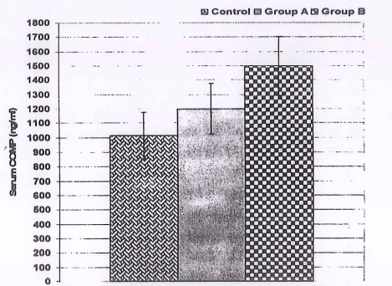
Fig (1): Mean (±SD) serum COMP levels estimated
in control and patients group
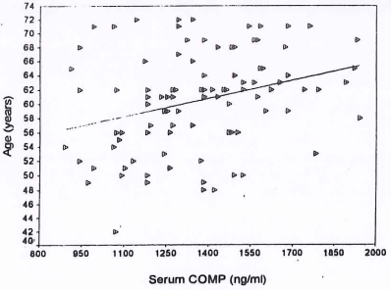 | 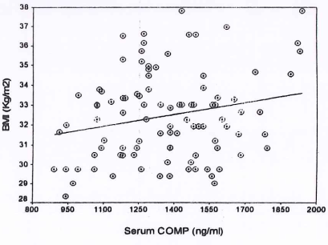
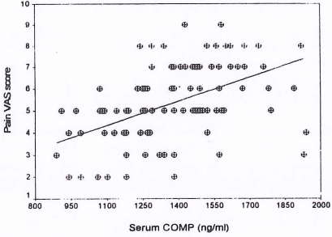 | 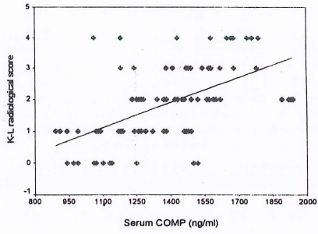
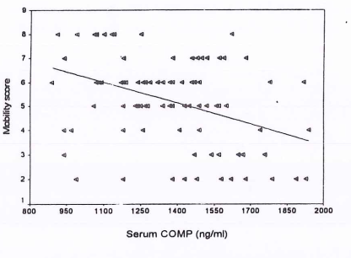 | Fig. (2): Correlation between serum COMP and clinical parameters and radiological scores of studied patients
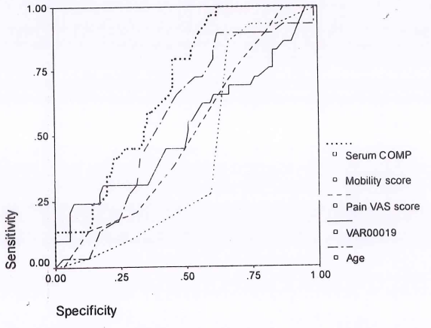
Fig. (3): Roc curve analysis of clinical parameters versus estimation of serum COMP for differentiation between patients with and without radiological finding of OA.
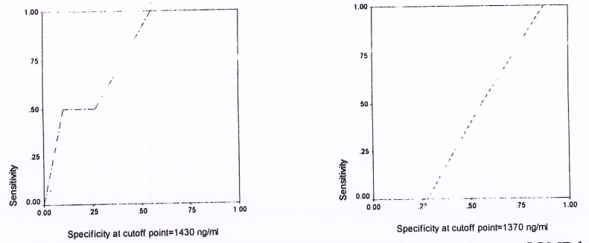
Fig. (4): Roc curve analysis for evaluation of specificity of serum COMP for differentiation between patients with and without radiological finding at 2 cutoff points.

DISCUSSION
An estimated 25% of the adult population aged ≥ 50 suffers from knee pain. In primary care, OA is the most common diagnosis for elderly patients with knee pain. Although, the connection between this diagnosis and the current disease-based classification of OA as well as the localized pain syndrome of knee pain and impairment remains unclear, ⁽¹⁶⁾.

This prospective research was conducted to examine the diagnostic usefulness of serum COMP estimation in individuals with atraumatic knee pain so as to classify OA patients.
The mean COMP serum level in the control group was 1015 ± 161.6 ng/ml, showing that COMP as a cartilage turnover marker is frequently present in serum, indicating that joint cartilage is regularly replaced. This conclusion was congruent with that of Neidhart et al., ⁽¹⁷⁾, who discovered elevated serum COMP levels in 7 out of 8 runners, whose blood levels spiked during the race and returned to baseline 24 hours later. higher baseline COMP levels may suggest an increase in joint matrix turnover due to previous intense physical training, Serum COMP is an indicator of diverse aspects of joint metabolism and/or injury in disease and athletics, as seen by the observed substantial rise while running, which may have been caused by a severe physical strain on joint structures.
Koelling et al., ⁽¹⁸⁾ discovered that in cartilage tissue both healthy & diseased, chondrocytes release COMP, which is frequently linked with collagen fibres. In OA late stages, chondrocytes adjacent to the main defect produce 5 times more COMP mRNA than chondrocytes in an area with macroscopically normal appearance.
These results indicate that COMP may have a function in the formation of the human limb, is elevated in OA, and may play a role in the pathogenesis of OA as a factor produced by chondrocytes to inhibit matrix disintegration due to its extensive binding repertoire, In addition, Andersson et al., ⁽¹⁹⁾ showed that during the night COMP serum levels are steady and decline dramatically during normal daytime activities, indicating a quick COMP clearance once it has reached the circulation.
Calculated mean serum COMP levels in cases were substantially higher than in the control group, while levels estimated in patients with OA radiological evidence were significantly higher than in the control group and significantly higher than in patients without who in turn were higher than control. Clinical parameters assessment vs. serum COMP estimation for distinguishing between cases with and without radiographic results using ROC curve analysis determined estimation of serum COMP to have the highest AUC. Significantly higher serum COMP levels in group A than control indicate an increase in the COMP serum test prior to the advent of radiographic evidence of OA, which increased as the disease progressed. Consequently, COMP serum levels could be utilised as a monitoring test for individuals with atraumatic knee pain in order to identify those at risk for developing OA and to diagnose those who already had OA. In support of these findings, serum COMP at a threshold value of 1370 ng/ml exhibited a high sensitivity rate of 76.4%, and at a cutoff value of 1430 ng/ml exhibited a high specificity rate of 86.4%; ROC curve analysis validated these findings.
In the transgenic mouse model of OA, protein redistribution & COMP mRNA overexpression are indicative of the early stages of articular cartilage degeneration, as documented by Salminen et al., ⁽²⁰⁾. Who was in the same line with our results. Vilim et al., ⁽²¹⁾ revealed that serum COMP is a potential prognostic marker of disease progression as he found that at baseline and after disease progression, serum COMP was positively correlated with knee joint space width, and that patients who progressed by 2 K-L grades had significantly higher COMP levels at baseline.
It was reported by Sharif et al., ⁽²²⁾ that at baseline in OA progressors, COMP serum level, AUC were significantly greater than non-progressors, and during radiographic progression COMP serum level was higher and determine progression periods. Additionally, the baseline COMP serum test was correlated with age, CRP, in adult patients with 3-month-old arthritis & joint score for swollen joints, revealing that cartilage involvement in both self-limiting and non-erosive disease is indicated by high COMP serum levels as reported by Soderlin et al. ⁽²³⁾.
In addition, Jung et al., ⁽²⁴⁾ determined by ultrasonography that the severity of the capsular distention correlated well with COMP serum levels, which were elevated in the more severe OA cases than in the less severe ones, cases with a longer medial osteophyte had elevated serum COMP levels than those with a shorter one. on ultrasonography, peripheral blood biochemical indicators directly reflect the soft tissue and/or bone of OA joints precise pathological alterations.

In a research conducted by Fernandes et al., ⁽²⁵⁾ discovered that cases with symptomatic knee OA had considerably greater COMP serum levels than controls and cases with asymptomatic articular space constriction. COMP serum levels of cases with knee OA clinical indications and no radiographic abnormalities (K/L grade 0 or 1) were significantly higher than controls.
In addition, Hunter et al. ⁽²⁶⁾ found that with the exception of COMP, 76% of cases investigated exhibited radiographic OA with K-L scale >2, All the investigated biomarkers were insignificant predictors of cartilage loss. on MRI in cases with symptomatic knee OA, increased COMP was the only predictor of further cartilage loss as the researchers reported. There was a substantial positive correlation between blood COMP levels and age, BMI, pain VAS score, and radiological grade, and a significant negative correlation between serum COMP levels and mobility score. Vilim et al. ⁽²⁷⁾ discovered that blood COMP levels were substantially linked with age, synovitis, and an interaction of synovitis and OA severity, with synovitis having the greatest effect on COMP levels. In addition, Wislowska and Jaboska ⁽²⁸⁾ found a link between the serum COMP level and the Western Ontario and McMaster University index pain scale for the lower limbs and the T-score value of densitometry tests in OA patients.
Estimation of serum COMP levels could be used as a screening test for patients with atraumatic knee pain to identify those at risk for developing OA and to diagnose patients already suffering from OA, with a high specificity rate of 86.4% at a level of 1430 ng/ml & a high sensitivity rate of 76.4% at a level of 1370 ng/ml.

REFERENCES
- Petersson I.F. & Jacobsson L.T. (2002): Osteoarthritis of the peripheral joints. Best Pract Res Clin Rheumatol.; 16: 741-60.
- Aszódi A.; Hunziker E.B.; Olsen B.R. & Fässler R. (2001) The role of collagen II and cartilage fibril-associated molecules in skeletal development. Osteoarthritis Cartilage; 9 (Suppl A): S150-9.
- Hyc A. Osiecka-Iwan A.; Jóźwiak J. & Moskalewski S. (2001): The morphology and selected biological properties of articular cartilage. Ortop Traumatol Rehabil. 3 (2): 151-62.
- Herrero-Beaumont G.; Guerrero R.; Sánchez- Pernaute O.; Acebes C.; Palacios 1.; Mas S.; Rodriguez I. Egido J. & Vivanco F. (2001) : Cartilage and bone biological markers in the synovial fluid of osteoarthritic patients after hyaluronan injections in the knee. Clin Chim Acta.; 308 (1-2): 107-15.
- Aigner T.; Zhu Y.; Chansky H.H.; Matsen F.A. III Maloney W.J. & Sandell L.J. (1999): Reexpression of type IIA procollagen by adult articular chondrocytes in osteoarthritic cartilage. Arthritis & Rheumatism; 42: 1443- 1450.
- Adams J.C. & Lawler J. (1993): The thrombospondin family. Curr. Biol. 3: 188-190.
- Hedbom E.; Antonsson P.; Hjerpe A.; Aeschlimann D.; Paulsson M.; Rosa-Pimentel E.; Sommarin Y.; Wendel M.; Oldberg Å. & Heinegård D. (1992): Cartilage matrix proteins. An acidic oligomeric protein (COMP) detected only in cartilage. J. Biol. Chem.; 267: 6132-6.
- Chen Z.; Heinegård D. & Sommarin Y. (1994): Distribution and expression of cartilage oligomeric matrix protein and bone matrix protein shows marked changes during rat femoral head development. Matrix Biol. 14:1 773-81.
- Rosenberg. K.H.; Olsson M. ; & Heinegard D. (1998) COMP shows high affinity Zn- dependent interaction with triple helical collagen. J. Biol. Chem.; 273: 20397-403.
- Holden P.R.S.; Meadows K.L.; Chapman M.E. ; Grant K.E.; Kadler and M.D. Briggs (2001): Cartilage oligomeric matrix protein interacts with type IX collagen, and disruptions to these interactions identify a pathogenetic mechanism in a bone dysplasia family. J. Biol. Chem.; 276: 6046-6055.
- Date H.; Yamada H.; Kanaji A.; Tajima K.; Hayakawa K.; Maehara K.; Miyazaki K.; Masuda H. World Health Organization (2007): Absolute risk for fracture and WHO guideline. Biological markers for osteoarthritis (OA). Clin Calcium.; 17(7): 1071-9.
- Huskisson E.C. (1974) Measurement of pain. Lancet; 2: 1127-31.
- Parker M.J. & Palmer C.R. (1993): A new mty
score for predicting mortality after hip fracture. J Bone Joint Surg.: 75B: 797-8.
- Kellgren J.H. & Lawrence JS. (1963):
Epidemiology of chronic rheumatism.
Philadelphia, Pa: Davis.
- Saxne T. & Heinegard D. (1992): Cartilage oligomeric matrix protein: a novel marker of cartilage turnover detectable in synovial fluid and blood. Br J Rheumatol.: 31: 583-91.
- Bruyere O.; Collette J.; Kothari M.; Zaim S.; White D.; Genant H.; Peterfy C.: Burlet N.; Ethgen D. Montague T.; Dabrowski C. & Reginster J.Y. (2006) Osteoarthritis, magnetic resonance imaging, and biochemical markers: a one year prospective study. Ann Rheum Dis. ; 65 (8): 1050-4.
- Neidhart M.; Müller-Ladner U.; Frey W.; Bosserhoff A.K.; Colombani P.C.; Frey- Rindova P.; Hummel K.M. Gay R.E.; Häuselmann H. & Gay S. (2000): Increased serum levels of non-collagenous matrix proteins (cartilage oligomeric matrix protein and melanoma inhibitory activity) in marathon runners. Osteoarthritis Cartilage; 3 (3): 222- 9.
- Koelling S.; Clauditz T.S.; Kaste M. & Miosge N. (2006) Cartilage oligomeric matrix protein is involved in human limb development and in the pathogenesis of osteoarthritis. Arthritis Res Ther. 8 (3): R56.
- Andersson M.L. Petersson I.F.; Karlsson K.E.; Jonsson E.N.; Månsson B.; Heinegård D. & Saxne T. (2006): Diurnal variation in serum levels of cartilage oligomeric matrix protein in patients with knee osteoarthritis or rheumatoid arthritis. Ann Rheum Dis.; 65 (11): 1490-4.
- Salminen H.; Perälä M.; Lorenzo P.; Saxne T.; Heinegård D. Säämänen A.M. & Vuorio E. (2000) Up-regulation of cartilage oligomeric matrix protein at the onset of articular cartilage degeneration in a transgenic mouse model of osteoarthritis. Arthritis Rheum.; 43 (8):1742-8.
- Vilim V. Olejárová M.; Machacek S.; Gatterová J. Kraus V.B. & Pavelka K. (2002) : Serum levels of cartilage oligomeric matrix protein (COMP) correlate with radiographic progression of knee osteoarthritis. Osteoarthritis Cartilage; 10 (9): 707-13.
- Sharif M.. Kirwan J.R.; Elson C.J Granell R. & Clarke S. (2004): Suggestion of nonlinear or phasic progression of knee osteoarthritis based on measurements of serum cartilage oligomeric matrix protein levels over five years. Arthritis Rheum; 50 (8): 2479-88.
- Soderlin M.K.; Kastbom A.; Kautiainen H.; Leirisalo-Repo M.; Strandberg G. & Skogh T. (2004) Antibodies against cyclic citrullinated peptide (CCP) and levels of cartilage oligomeric matrix protein (COMP) in very early arthritis: relation to diagnosis and disease activity. Scand J Rheumatol.; 33 (3): 185-8.
- Jung Y.O.; Do J.H.; Kang H.J.; Yoo S.A.; Yoon CH. Kim H.A. Cho C.S. & Kim W.U. (2006) : Correlation ofnographic severity with biochemical marker of synovium and cartilage in knee osteoarthritis patients. Clin. Exp Rheumatol. 24 (3): 253-9.
- Fernandes F.A.; Pucinelli M.L.; da Silva N.P. & Feldman D. (2007): Serum cartilage oligomeric matrix protein (COMP) levels in knee osteoarthritis in a Brazilian population: clinical and radiological correlation. Scand J Rheumatol. 36:211-5.
- Hunter D.J., Li J, Lavalley M.; Bauer D.C.; Nevitt M.; Degroot J.; Poole R.; Eyre D.. Guermazi A.; Gale D. & Felson D.T (2007) : Cartilage markers and their association with cartilage loss on MRI in knee osteoarthritis: The Boston Osteoarthritis Knee Study. Arthritis Res Ther; 9(5): R108.
- Vilim V.; Vytásek R.; Olejárová M.; Machacek S.; Gatterová J.; Procházka B.; Kraus V.B. & Pavelka K. (2001): Serum cartilage oligomeric matrix protein reflects the presence of clinically diagnosed synovitis in patients with knee osteoarthritis. Osteoarthritis Cartilage: 9 (7) 6128.
- Wisłowska M. & Jabłońska B. (2005): Serum cartilage oligomeric matrix protein (COMP) in rheumatoid arthritis and knee osteoarthritis. Ciin Rheumatol. 24 (3): 278-84.

الملخص العربي

نظرة على النشوء المرضى لفقر الدم المصاحب للأمراض المزمنة المسبب بداء الذئبة الحمراء

السيد المنزلاوي فيصل عمران، نهي عبد الناصر ، اسماعیل محمود *** وبشير حمزة ***

اقسام الروماتيزم والتأهيل بكليات الطب - جامعتي الأزهر وبنها ، وقسم الباثولوجيا الأكلينيكية * * بمستشفيات وزارة الصحة بالمملكة العربية السعودية * ودولة الأمارات المتحدة

صممت الدراسة الحالية لتقييم تردد حدوث فقر دم الأمراض المزمنة في المرضى بداء الذئبة الحمراء ولقياس مستويات الأنترلوكين- ٦ ، وعامل تحفيز انتاج كرات الدم الحمراء بمصل الدم ومدى إيجابية مصل الدم للأجسام المضادة لعامل تحفيز انتاج كرات الدم الحمراء في مرضى داء الذئبة الحمراء لكي تقيم دورهم المحتمل في نشوء فقر دم الأمراض المزمنة.

تضمنت الدراسة ۲۰۰ مريضا بداء الذئبة الحمراء، تم التحديد الأكلينيكى لمدى نشاط المرض باستخدام مقياس مجموعة الجزر البريطانية لتقييم داء الذئبة، أعتبر تركيز الهيموجلوبين عند أو أقل من ١٢ جرام/ ديسيمتر للاناث و عند أو أقل من ١٣,٥ جرام/ديسيمتر للرجال المستوى المحدد لوجود فقر الدم المصاحب للأمراض المزمنة وتم قياس مستوى كل من الأنترلوكين- ٦ وعامل تحفيز انتاج كرات الدم الحمراء وتحديد مدى إيجابية مصل الدم للأجسام المضادة لعامل تحفيز انتاج كرات الدم الحمراء.

إكتشف مخطط الدمّ ۷۳ مرضى بفقر دم الأمراض المزمنة (مجموعة أنيمية)؛ أعتبر المرضى الآخرون (مجموعة غير أنيمية)، كان هناك إرتباط سلبي ذو دلالة احصائية بين تركيز الهيموجلوبين ومعدل النشاط الدموى لمرض الذئبة الحمراء.

كان معدل الأنترلوكين - ٦ بمصل الدم أعلى بدرجة ذات دلالة إحصائية فى المرضى مقارنة بالمجموعة الضابطة، وفي المجموعة الأنيمية مقارنة بالمجموعة الضابطة وغير الأنيمية، وفى المجموعة غير الأنيمية مقارنة بالمجموعة الضابطة، تم تحديد إيجابية مصل الدم للأجسام المضادة لعامل تحفيز انتاج كرات الدم الحمراء في ۱۰٥مريض (٥۲٫٥%) بينما المرضى الآخرون الـ ٩٥( ٤٧,٥ %) كانوا سلبيون لهذه الأجسام المضادة وكان مستوى عامل تحفيز انتاج كرات الدم الحمراء بمصل الدم أقل بدرجة ذات دلالة احصائية في غير الحاملين لهذه الأجسام المضادة مقارنة بحاملى هذه الأجسام المضادة وكان مستواه أعلى بدرجة ذات دلالة إحصائية في المجموعة الأنيمية مقارنة بالمجموعة ، ووجد ارتباط سلبي ذو دلالة احصائية بين تركيز الهيموجلوبين وإيجابية مصل الدم للأجسام المضادة لعامل تحفيز انتاج كرات الدم الحمراء ومعدل كلا عامل تحفيز انتاج كرات الدم الحمراء والأنترلوكين - ٦ بمصل الدم بينما كانت العلاقة بين الأنترلوكين - ٦ و عامل تحفيز انتاج كرات الدم الحمراء ايجابية ذات دلالة إحصائية.

حدد تقييم المؤشرات المضمنة للنشوء المرضي لفقر الدم المصاحب لداء الذئبة الحمراء باستعمال منحنى التحليل المحكم بالمنطقة تحت المنحنى مستوى الأنترلوكين- ٦ بمصل الدم كالعامل الأكثر تعيينا يليه إيجابية مصل الدم للأجسام المضادة لعامل تحفيز انتاج كرات الدم الحمراء ثم معدل عامل تحفيز انتاج كرات الدم الحمراء.

يُمكن أن يُستنتج ان تردد حدوث فقر الدم المصاحب للمرض المُزمن بسبب الأصابة بداء الذئبة الحمراء هو ٣٦,٥ % و إيجابية مصل الدم للأجسام المضادة لعامل تحفيز انتاج كرات الدم الحمراء وارتفاع مستوى الأنترلوكين - ٦- بمصل الدم لها دور مكمل في نشونه المرضي.

